/ is the root directory

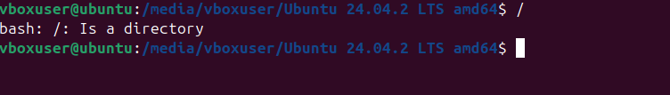

Pwd –present working directory



Cd – change directory

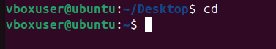

Cd .. – used to one step back



Cd ../.. – used to two steps back



ls – list of files

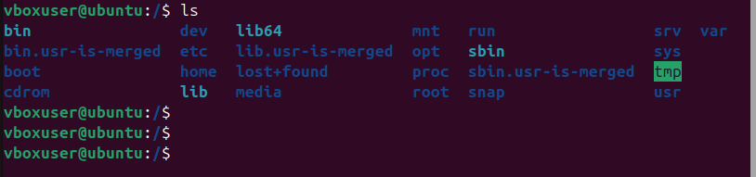

Date – display the system date and time

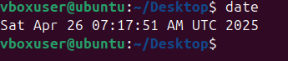

ll –list of files with details

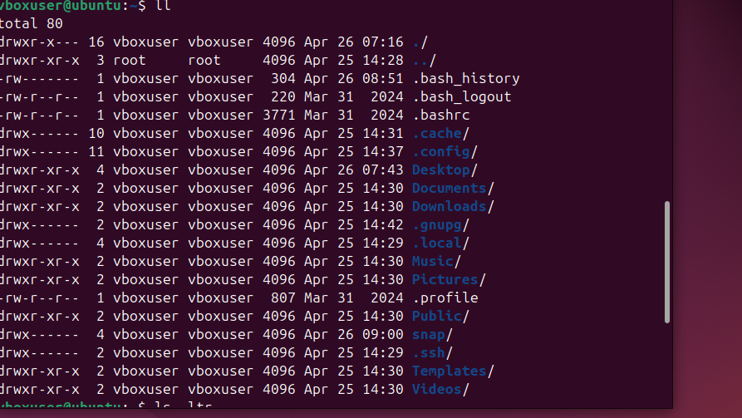

ls –ltr –list files and directories in a long format

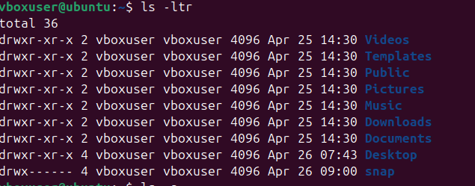

ls –l –list long

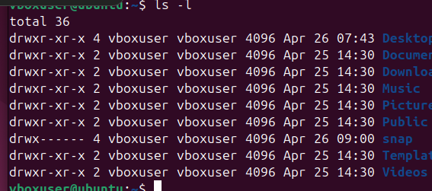

ls –a –list of files +hidden files



Mkdir –to create a directory

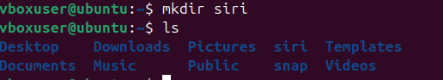

mv –rename and move directory to other file

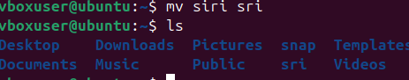

Clear –removes all text from the terminalscreen



touch – to create a new file

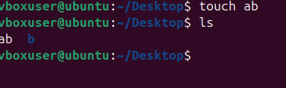

vi –to add text/content to the file

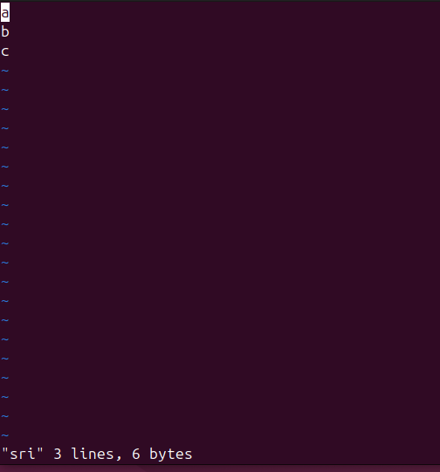

cat –to read the text/content in the file

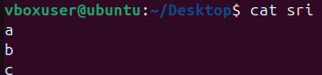

wc –word count of file

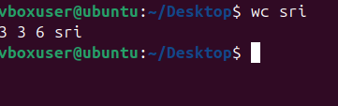

history –display a list of commands that have been entered into the terminal

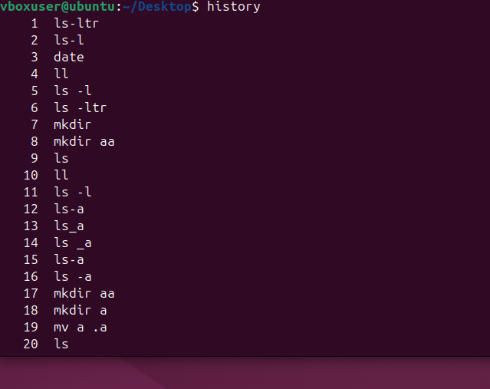

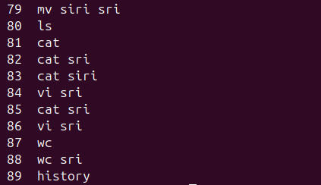

Rm –rf – to delete the directories

